8.219.69.17
open alibabacloud console
sudo -i
passwd (Z@w.5432!Zaw)
hostnamectl
sudo hostnamectl set-hostname odoo
sudo reboot
sudo apt update && sudo apt upgrade -y
sudo adduser ztmaung (Z@w.5432!)
sudo usermod -aG sudo ztmaung
sudo usermod -aG root ztmaung
su – ztmaung

sudo apt update && sudo apt upgrade -y
sudo apt install \
ca-certificates \
curl \
gnupg \
lsb-release -y

sudo mkdir -p /etc/apt/keyrings
curl -fsSL https://download.docker.com/linux/$(. /etc/os-release; echo "$ID")/gpg | sudo gpg --dearmor -o /etc/apt/keyrings/docker.gpg

echo \
"deb [arch=$(dpkg --print-architecture) signed-by=/etc/apt/keyrings/docker.gpg] https://download.docker.com/linux/$(. /etc/os-release; echo "$ID") \
$(lsb_release -cs) stable" | sudo tee /etc/apt/sources.list.d/docker.list > /dev/null

sudo apt update
sudo apt install docker-ce docker-ce-cli containerd.io docker-buildx-plugin docker-compose-plugin -y

sudo docker run hello-world

sudo usermod -aG docker $USER

docker compose version

sudo apt update && sudo apt upgrade -y
open mobaexterm with public ip ( password Z@w.5432!)

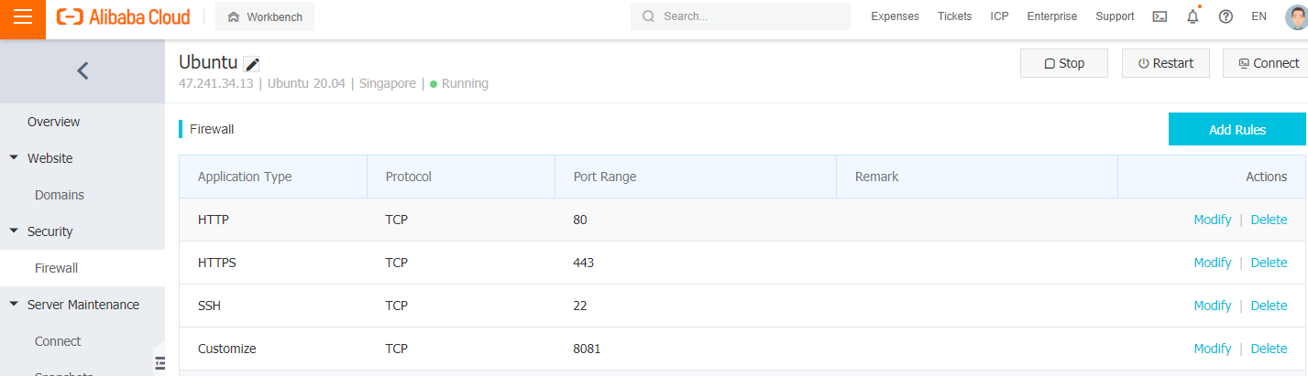
sudo usermod -aG docker ztmaung
sudo usermod -aG docker root

